
Touchstones
Netcards

Mercy Netcards with Text

Boxing HRJ
Broken HRJ
Courtroom HRJ
Despairing Man HRJ



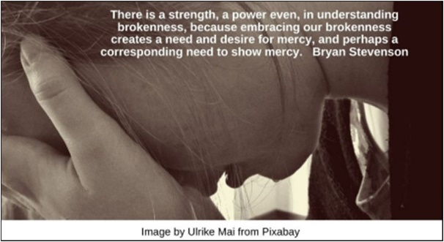

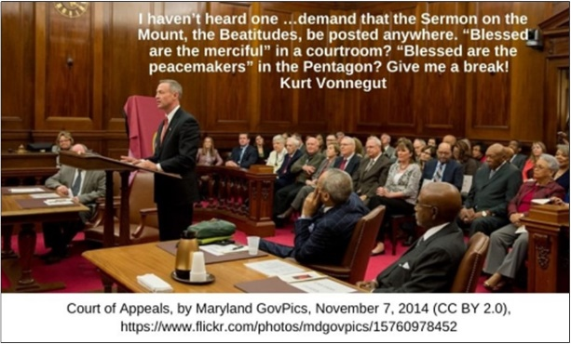


Dog Pound HRJ
Dove HRJ
Freedom HRJ
Good Shepherd HRJ

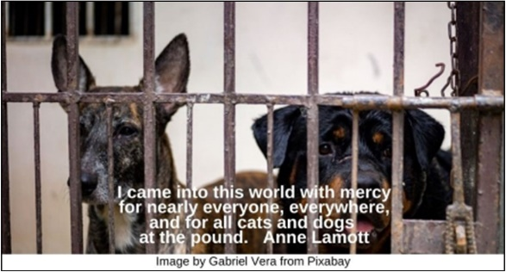







Hate HRJ
Heaven HRJ
Homeless HRJ
Hunger HRJ

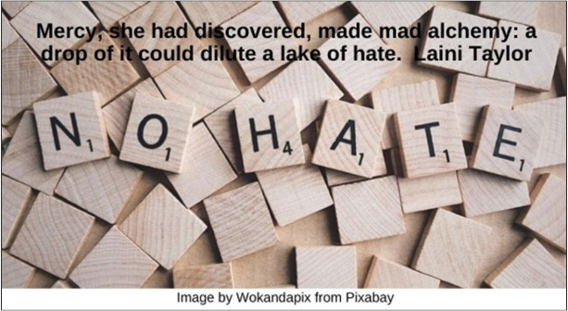

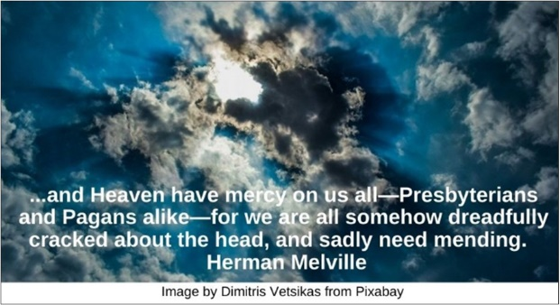

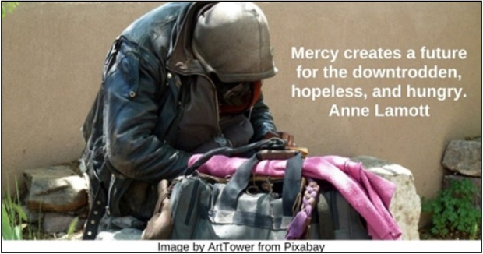

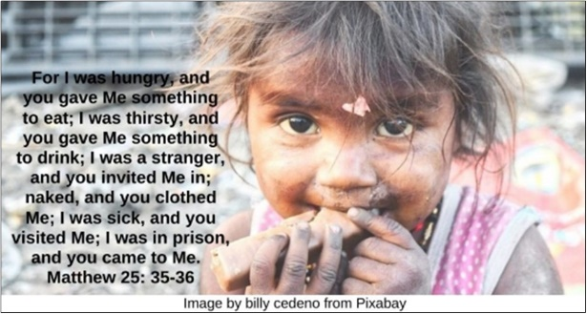

James Baldwin HRJ
Kindness HRJ
Lincoln HRJ
Love Mercy HRJ

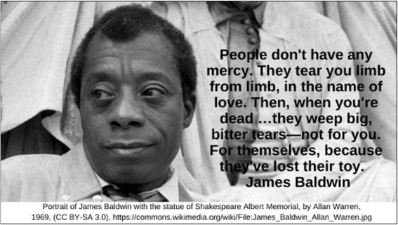

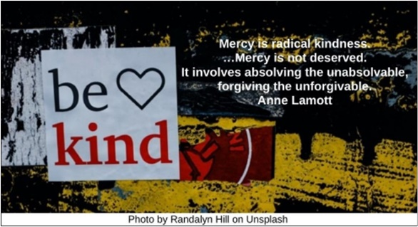

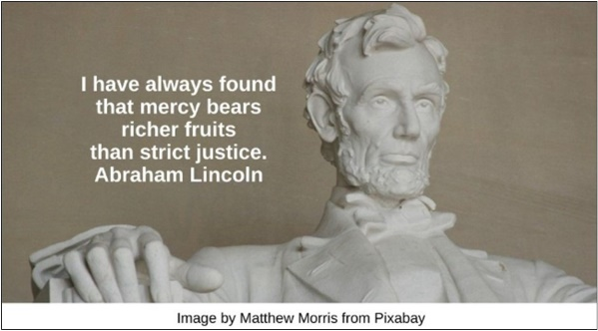



Nelson Mandela HRJ
Night HRJ
Percentage HRJ
Prison Cell HRJ

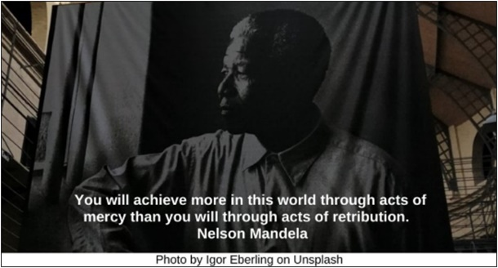

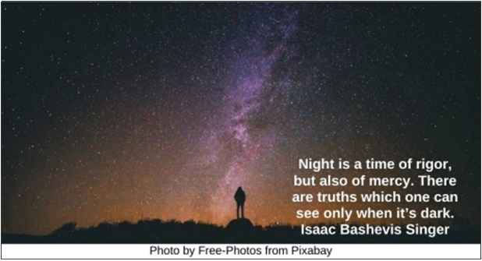

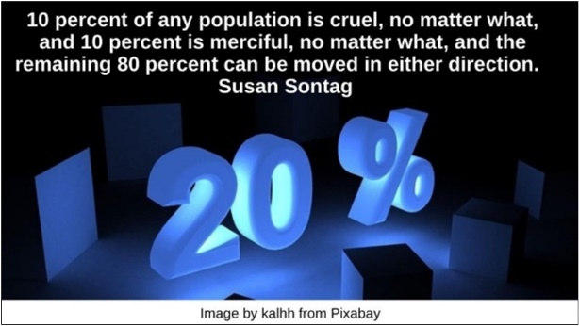

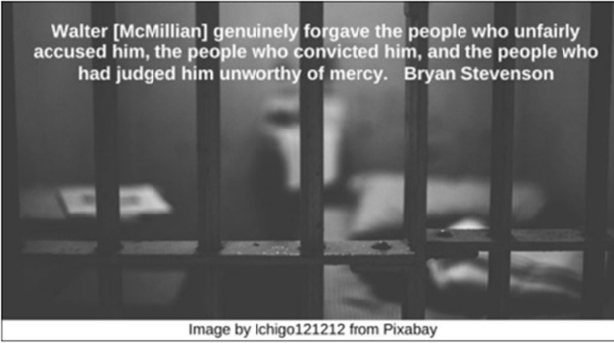

Prophet HRJ
Rags HRJ
Rain HRJ
Rainbow HRJ



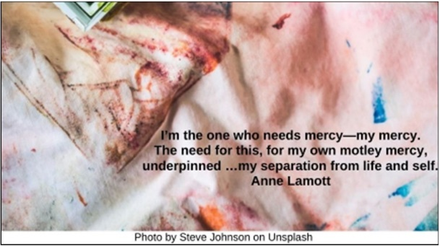



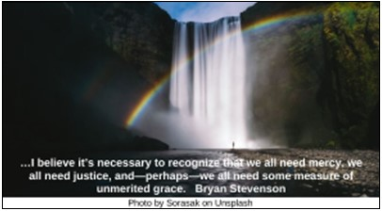

Rat HRJ
Scales of Justice HRJ
Sorry HRJ
Spider Web HRJ

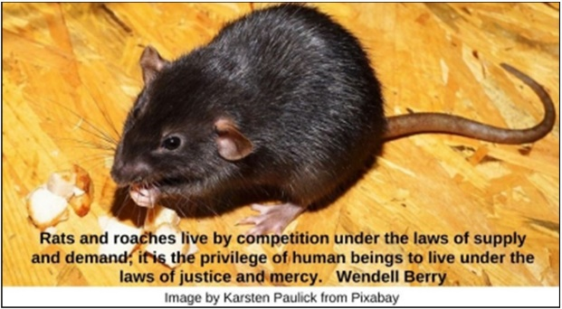



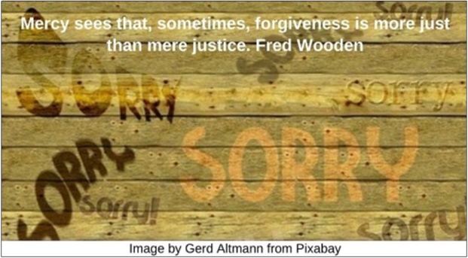

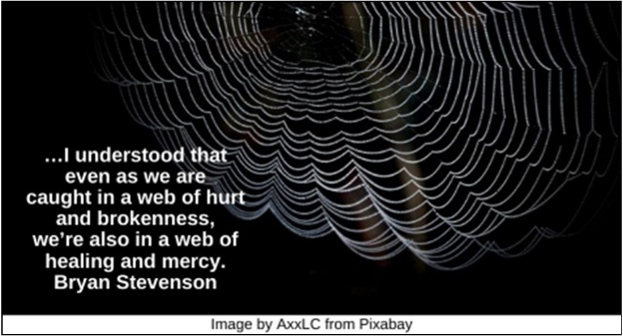

Suffering HRJ
World HRJ
Zoo HRJ

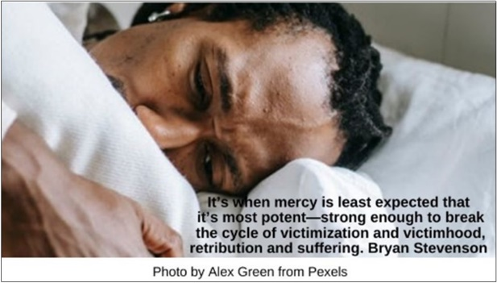

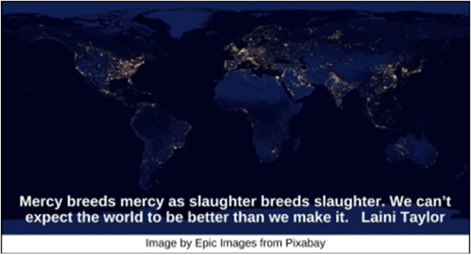

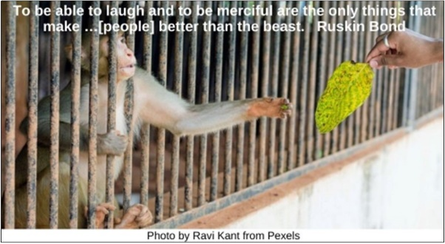

Text of Quotes

Boxing HRJ
The world will give you that once in a while, a brief timeout; the boxing bell rings and you go to your corner, where somebody dabs mercy on your beat-up life. Sue Monk Kidd

Broken HRJ
There is a strength, a power even, in understanding brokenness, because embracing our brokenness creates a need and desire for mercy, and perhaps a corresponding need to show mercy. Bryan Stevenson

Courtroom HRJ
I haven’t heard one …demand that the Sermon on the Mount, the Beatitudes, be posted anywhere. “Blessed are the merciful” in a courtroom? “Blessed are the peacemakers” in the Pentagon? Give me a break! Kurt Vonnegut

Despairing Man HRJ
Only the man who has had to face despair is really convinced that he needs mercy. …A life that is without problems may literally be more hopeless than one that always verges on despair. Thomas Merton

Dog Pound HRJ
I came into this world with mercy for nearly everyone, everywhere, and for all cats and dogs at the pound. Anne Lamott

Dove HRJ
Blessed are the merciful: for they shall obtain mercy. Matthew 25.7

Freedom HRJ
…I surrender to …mercy because I do not have any other answers that will set people free. Ron Raab

Good Shepherd HRJ
The main message of Jesus, I believed, is that mercy trumps justice every time. Paul Kalanithi

Hate HRJ
Mercy, she had discovered, made mad alchemy: a drop of it could dilute a lake of hate. Laini Taylor

Heaven HRJ
...and Heaven have mercy on us all—Presbyterians and Pagans alike—for we are all somehow dreadfully cracked about the head, and sadly need mending. Herman Melville

Homeless HRJ
Mercy creates a future for the downtrodden, hopeless, and hungry. Anne Lamott

Hunger HRJ
For I was hungry, and you gave Me something to eat; I was thirsty, and you gave Me something to drink; I was a stranger, and you invited Me in; naked, and you clothed Me; I was sick, and you visited Me; I was in prison, and you came to Me. Matthew 25: 35-36

James Baldwin HRJ
People don't have any mercy. They tear you limb from limb, in the name of love. Then, when you're dead …they weep big, bitter tears—not for you. For themselves, because they've lost their toy. James Baldwin

Kindness HRJ
Mercy is radical kindness. …Mercy is not deserved. It involves absolving the unabsolvable, forgiving the unforgivable. Anne Lamott

Lincoln HRJ
I have always found that mercy bears richer fruits than strict justice. Abraham Lincoln

Love Mercy HRJ
The longer I live, the more I read, the more patiently I think, and the more anxiously I inquire, the less I seem to know.... Do justly. Love mercy. Walk humbly. This is enough. John Adams

Nelson Mandela HRJ
You will achieve more in this world through acts of mercy than you will through acts of retribution. Nelson Mandela

Night HRJ
Night is a time of rigor, but also of mercy. There are truths which one can see only when it’s dark. Isaac Bashevis Singer

Percentage HRJ
10 percent of any population is cruel, no matter what, and 10 percent is merciful, no matter what, and the remaining 80 percent can be moved in either direction. Susan Sontag

Prison Cell HRJ
Walter [McMillian] genuinely forgave the people who unfairly accused him, the people who convicted him, and the people who had judged him unworthy of mercy. Bryan Stevenson

Prophet HRJ
This is so subversive. All I have to do in order to begin again is to love mercy, if I am to believe [the] nutty old [prophet] Micah. Anne Lamott

Rags HRJ
I’m the one who needs mercy—my mercy. The need for this, for my own motley mercy, underpinned …my separation from life and self. Anne Lamott

Rain HRJ
The quality of mercy is not strain'd, / It droppeth as the gentle rain from heaven…. William Shakespeare

Rainbow HRJ
…I believe it’s necessary to recognize that we all need mercy, we all need justice, and—perhaps—we all need some measure of unmerited grace. Bryan Stevenson

Rat HRJ
Rats and roaches live by competition under the laws of supply and demand; it is the privilege of human beings to live under the laws of justice and mercy. Wendell Berry

Scales of Justice HRJ
Mercy was more frightening than murder, because it was harder. Kristin Cashore

Sorry
Mercy sees that, sometimes, forgiveness is more just than mere justice. Fred Wooden

Spider Web HRJ
…I understood that even as we are caught in a web of hurt and brokenness, we’re also in a web of healing and mercy. Bryan Stevenson

Suffering HRJ
It’s when mercy is least expected that it’s most potent—strong enough to break the cycle of victimization and victimhood, retribution and suffering. Bryan Stevenson

World HRJ
Mercy breeds mercy as slaughter breeds slaughter. We can’t expect the world to be better than we make it. Laini Taylor

Zoo HRJ
To be able to laugh and to be merciful are the only things that make …[people] better than the beast. Ruskin Bond

